

CSF 3133

REKA BENTUK ANTARA MUKA BERASASKAN WEB

NAME: NIK MARIYAH SOFEAH BINTI MOHD RIZAN

MATRIC NUMBER: S76237

GROUP: K4

LECTURER: PROF.MADYA TS. DR. WAN NURAL JAWAHIR HJ WAN YUSSOF

DATE: 19/11/2025

SEMESTER I 2025/2026

Inline CSS

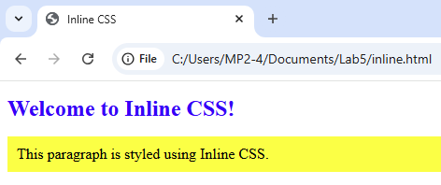

Internal CSS

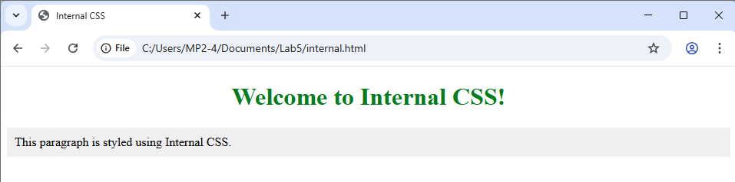

External CSS

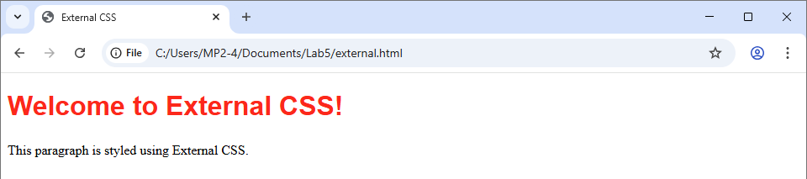

Link to file CSS (from another website)

Using Roboto font

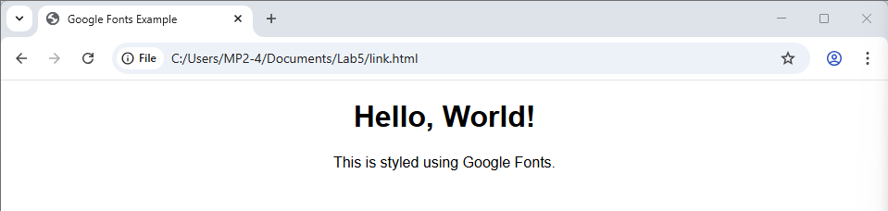

Using Calibri font

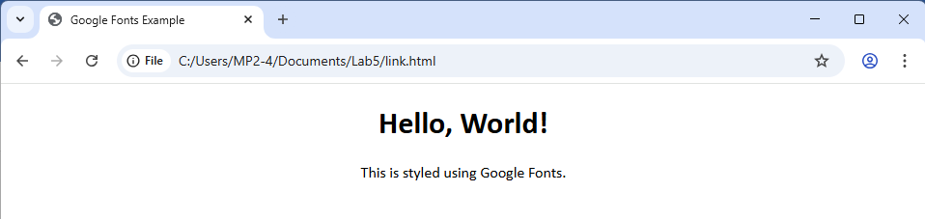

CSS Background

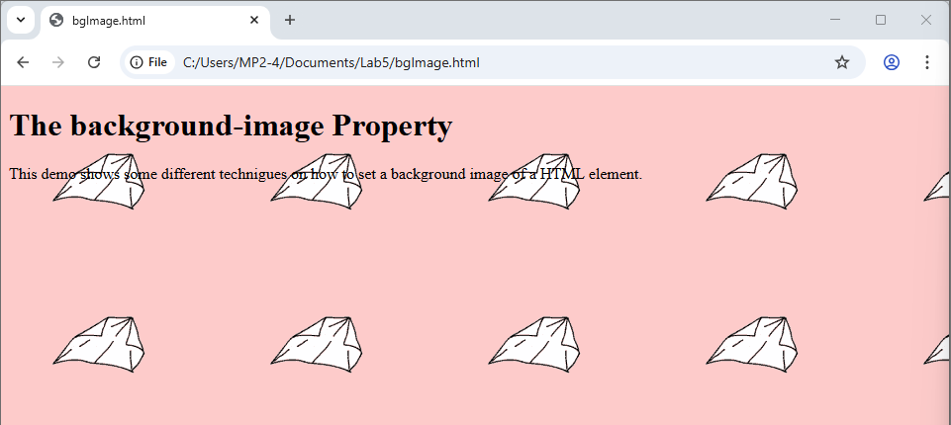

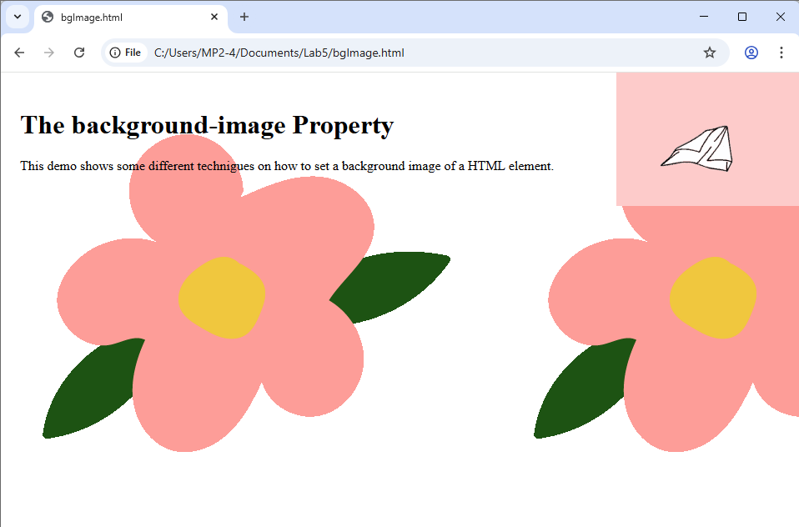

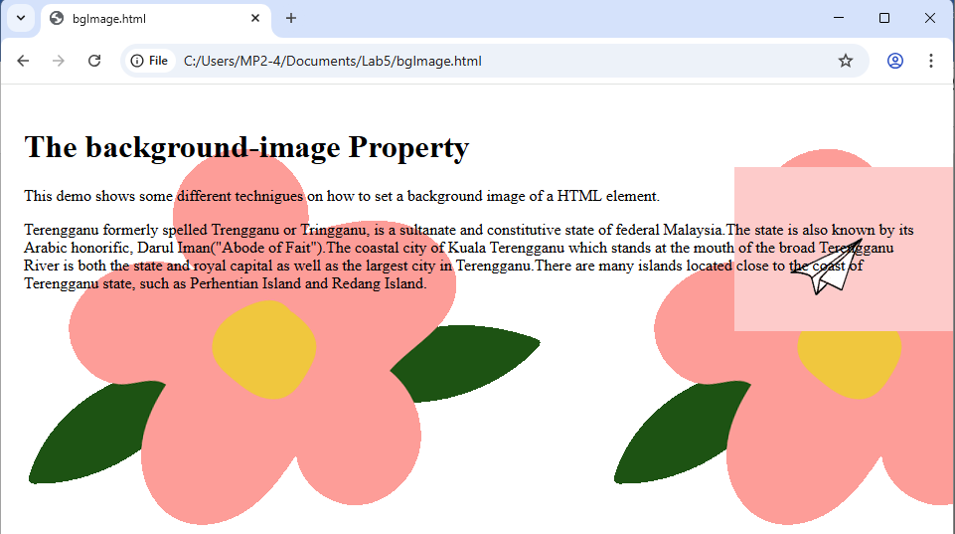

CSS Table

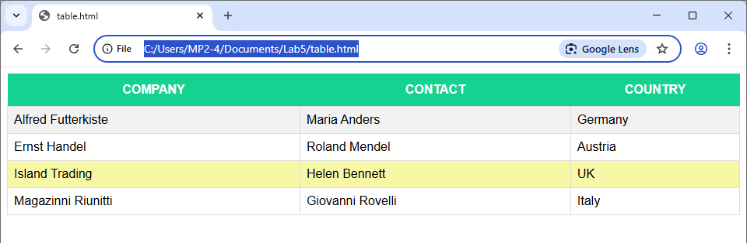

CSS Navigation

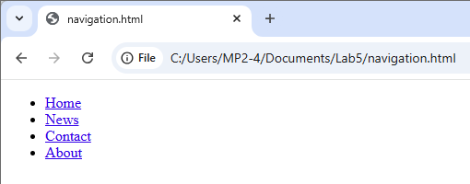

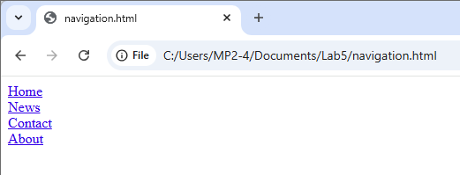

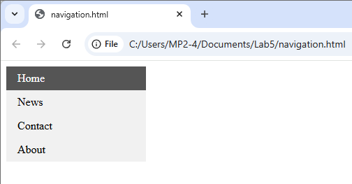

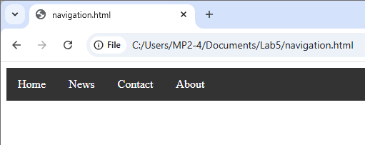

Lab Exercise

